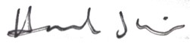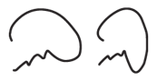

Hannah Wojno Director

Good Deeds Day

Kaynan Rabino CEO

Good Deeds Day

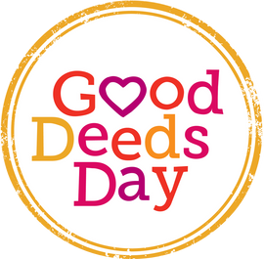

Certificate of Gratitude

AWARDED TO:

**..................**

# for your contribution and doing good on Good Deeds Day 2025

Thank you for your devotion, initiative, commitment and your big heart! You've helped make this day especially successful. For over a decade, doing good together has helped promote the spirit of volunteering and giving around the globe.

# We look forward to doing good together again on April 12, 2026!

Add your signature

your name your title

your organization name