
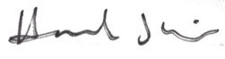
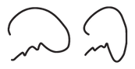
Hannah Wojno Director
Good Deeds Day
Kaynan Rabino CEO
Good Deeds Day

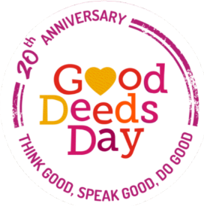
Certificate of Gratitude
AWARDED TO:

..................

for your contribution and doing good on Good Deeds Day 2026

Thank you for your devotion, initiative, commitment and your big heart! You've helped make this day especially successful. For over two decades, doing good together has helped promote the spirit of volunteering and giving around the globe.

We look forward to doing good together again on April 18, 2027!

Add your signature

your name your title
your organization name

